**INTRODUCTION**

In today's fast-paced world, coffee shops have become a popular destination for people to grab a quick cup of coffee or to spend time with friends and colleagues. The increasing demand for coffee has led to the growth of the coffee shop industry, which has become a competitive marketplace. In order to thrive in this competitive industry, coffee shop owners need to be able to manage their operations efficiently.

A coffee shop management system is a software application designed to help coffee shop owners manage their operations. It provides tools for managing menu items, orders, inventory, sales, and payments. Using a coffee shop management system, owners can streamline their operations, reduce errors, and improve customer experience.

This documentation provides an overview of a coffee shop management system and its functionalities. It includes details on the system's requirements, design, and installation instructions.

The intended audience for this documentation is coffee shop owners, managers, and IT professionals who are responsible for managing coffee shop operations. The readers are assumed to have a basic understanding of computer systems and software applications.

This documentation is structured as follows:

* **Section 1** provides an overview of the coffee shop management system and its purpose.
* **Section 2** outlines the system requirements, including hardware, software, and network requirements. Explains the system's design, including the architecture and modules of the system.
* **Section 3** details the system's functionalities, including menu management, order management, inventory management, sales reporting, and payment integration.
* **Section 4** covers system maintenance and support.

Overall, this document aims to provide a comprehensive guide to using the coffee shop management system to improve the efficiency of coffee shop operations.

**Section 1**

**METHODOLOGY**

# **Project Overview**

The coffee shop web app is a simple management platform designed to help coffee shop owners manage their customers' orders, update their menus, and track their sales. The target audience for the web app is coffee shop owners, employees, and customers who are looking for a simple and user-friendly way to place and track their orders.

# **Project Scope**

The web app has two main parts: a user interface and an admin panel. The user interface allows customers to place their orders, input their name and address, and view their order history. The admin panel allows the coffee shop owner to update the menu, view orders, and update customer information. The project deliverables include a functional user interface, a secure admin panel, and a working database to store customer and order information.

# **Development Approach**

The development team followed a DevOps approach for the coffee shop web app project. The team emphasised continuous collaboration, communication, and automation between development and operations teams to increase software delivery speed and quality. The team conducted testing throughout the development process to ensure that the web app was functioning correctly. After testing was complete, the web app was deployed to a web server for public access."

**Tools and Technologies**

The web app was developed using ASP.NET, a popular web application framework developed by Microsoft. The team used Visual Studio as their integrated development environment (IDE) and SQL Server for the database management system.

# **Timeline**

The project timeline was two and a half months, broken down into four sprints. The team allocated two weeks for each sprint, with a week in between sprints for planning and review.

# **Testing and Deployment**

The team conducted testing throughout the development process to ensure that the web app was functioning correctly. The team conducted functional and performance testing to identify any bugs or issues.

**Section 2**

**System Requirements**

1. Operating system: Windows to be precise.
2. Web Browser: Google Chrome, Mozilla Firefox, or Safari
3. Internet connection
4. Minimum hardware requirements:2 GHz Processor, 4GB RAM, 100GB hard disk space

**Section 3**

**Functionalities**

* **Order management:** A cafe management system allows the cafe staff to manage orders effectively, from taking orders to preparing, utensils, and other items needed to run the cafe. The system should allow the cafe staff to monitor the stock levels.
* **Sales reporting:** A cafe management system should provide them with delivery. The system should allow the staff to view and manage orders in real-time, update order status, and track the progress of orders.
* **Inventory management:** This feature allows the cafe owner to manage their inventory, including food and beverage ingredients and comprehensive sales reports that help the cafe owner track sales trends and make informed business decisions. The system should allow the owner to analyse sales data by product, time period, and other parameters to identify the top-selling items and improve the cafe's overall profitability
* **Payment integration:** The system should allow the cafe staff to process payments easily and securely, including accepting multiple payment methods such as credit cards, cash, and mobile payments. The system should also generate receipts and manage refunds if necessary.
* **Menu management:** The menu management feature of a cafe management system allows the cafe owner to manage their menu items, including adding or removing items, updating prices, and setting up menu combinations. The system should allow the owner to easily create and update the menu, including adding images and descriptions of the menu items.

**System Screenshots.**

**Login and sign up**

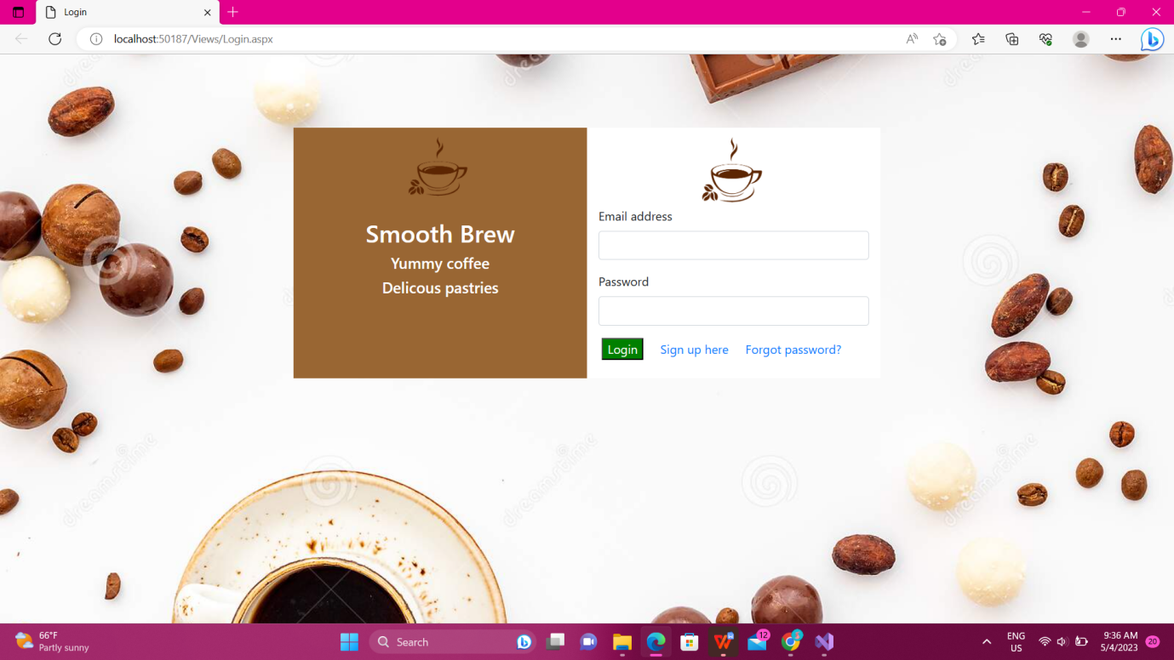

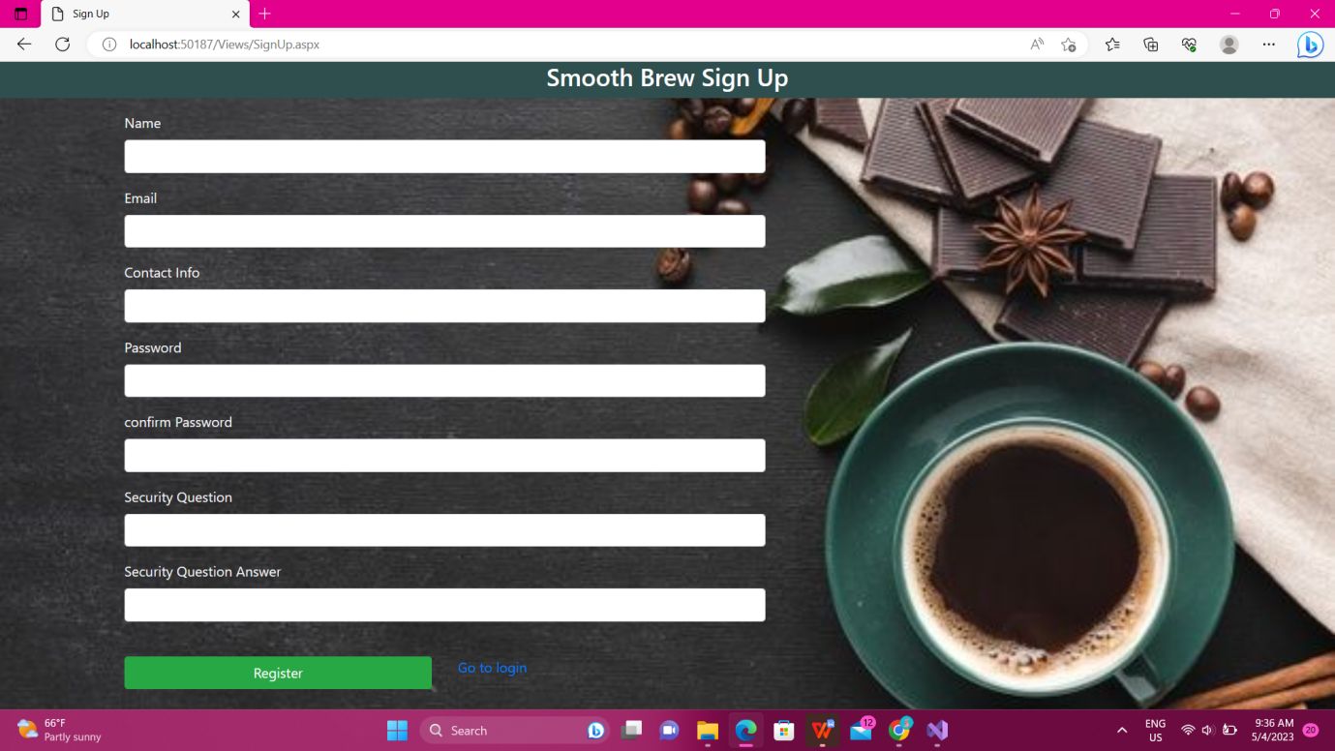

**User order**

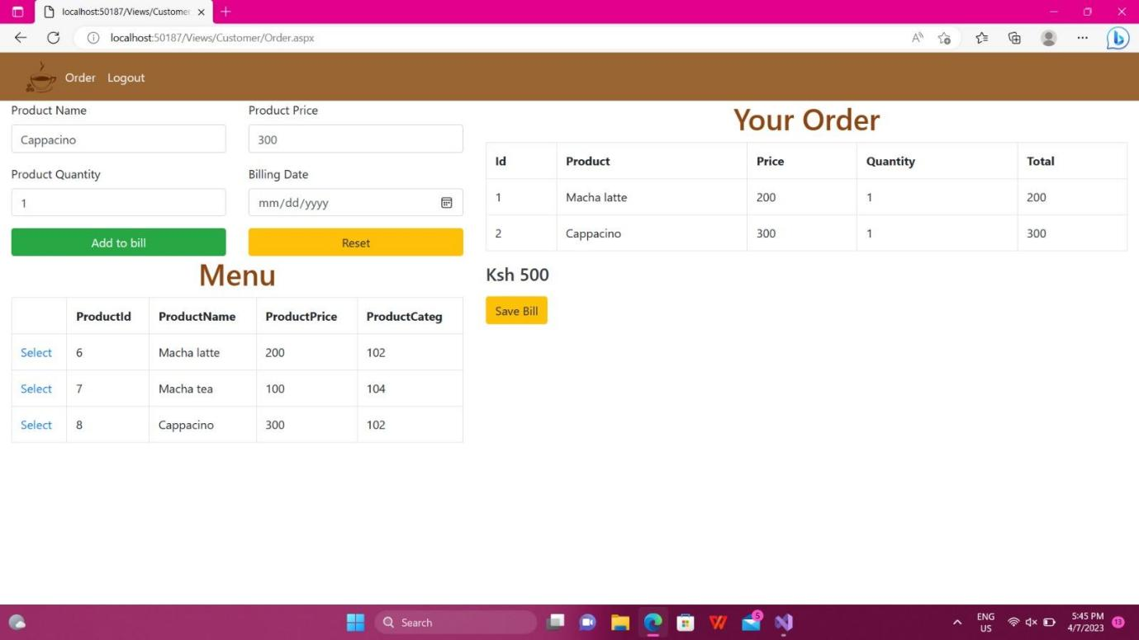

**Forgot Password**

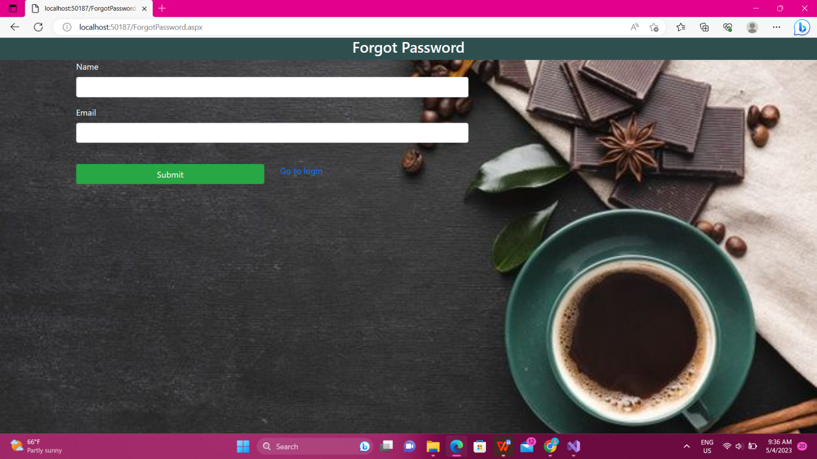

**Admin products**

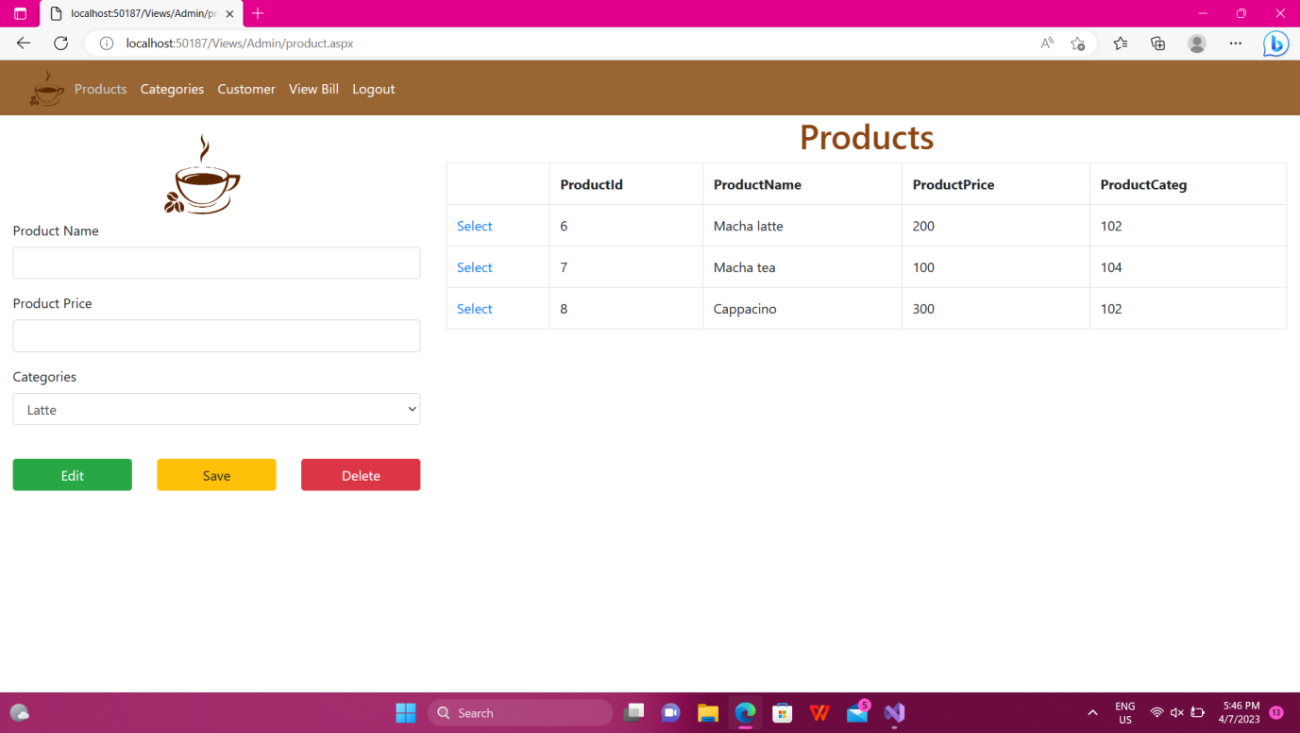

**Admin Categories**

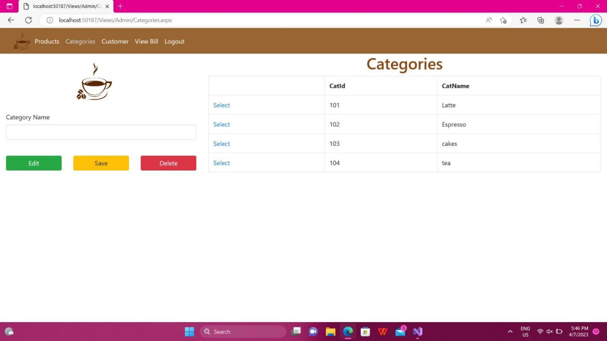

**Admin view customer bill**

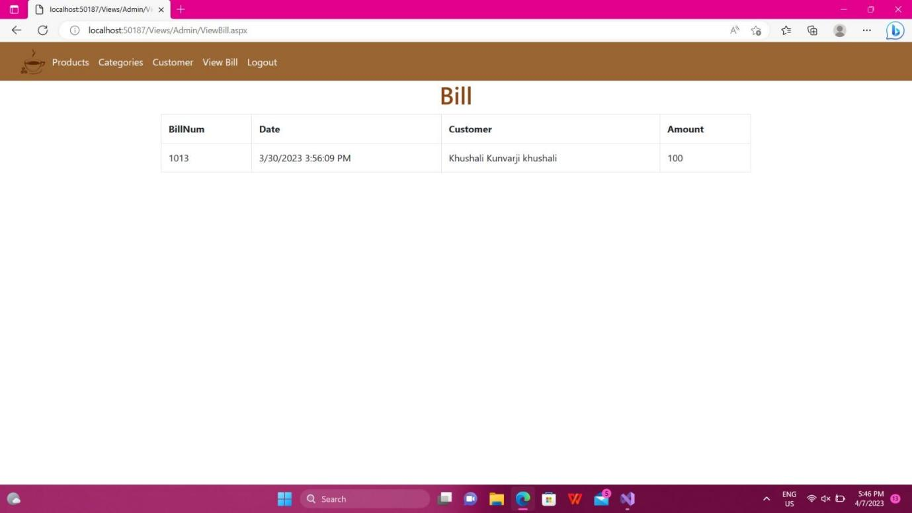

**Admin view customers**

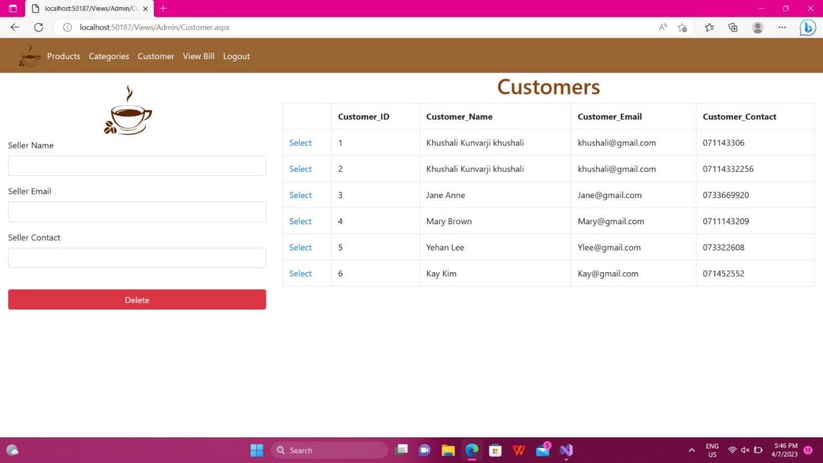

**Section 4**

**System maintenance and support**

To ensure smooth operations, a cafe management system should be regularly maintained and updated to fix bugs and improve system performance. The system should also have a reliable customer support team that can provide technical assistance and resolve issues.

In summary, a cafe management system should have functionalities such as order management, inventory management, sales reporting, payment integration, and menu management, and should also include system maintenance and support to ensure efficient and effective operations

**Conclusion**

The target market of our cafe shop is the youth. So special concessions are given to students. This familiarises the shop with the target customers. Free Wi-Fi is also provided to attract more youngsters. A gift coupon is given to a customer to encourage a return. The purpose of the coupon is that the customer visits again. We also let the students which are our most estimated clients a chance to rate the services on our web.

**Acknowledgment**

We sincerely thank Mr. Edward Kioko for allowing us to expand our knowledge and use it in the project. A special thanks for his assistance and guidance in the further development of this project.

**REFERENCES**

[www.w3schools.com](http://www.w3schools.com), Programming ASP.NET (Jesse Liberty, 2002), C# in depth, YouTube, Geekforgeeks.